TITLE
A.F. Ivanov¹,I.I. Petrov^{1*}, S.V. Sidorov², A.A. Kuznetsov¹
¹Moscow State University, Department of Chemistry
²Institute of Synthetic Polymer Materials RAS
*e-mail: petrov@mail.net
Document format: Microsof Word (*.docx).
All margins: 2,5 cm. Font: Times New Roman with single line spacing.
Title: capital bold 12 pt, alignment – center. Indent 12 pt.
Authors’ names: italic 12 pt, alignment – center, name of the speaker should be underlined. Indent 6 pt.
Organization(s) (only names of the organizations without their addresses) and e-mail: normal 12 pt, alignment – center. Indent 12 pt.
Text: 1 full page, normal 12 pt, alignment – justified, no paragraph indent.
References: normal 10 pt, name of the journal should be italic, volume - bold.
Figures should be inserted in line with text.
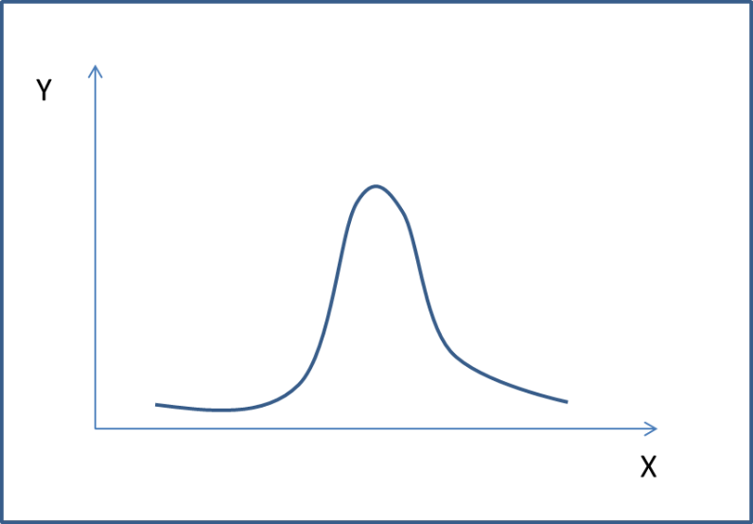
Fig. 1. Figure title
Figure title: below figures, normal 12 pt, alignment – center. Indent 6 pt.
Gratitude for financial support should be below body text, italic 10 pt.
This work was supported by RScF (project № 00-00-00000).

Ivanov I.I., Zuzin R.V. Organomet.Chem. 2003, 21(1), 144-150.

